|  |  |
| --- | --- |
| **C.B.S.E. No. 1030429** |  |

Term–I Worksheet- 2 (2017-18)

Class-1st

Subject-EVS

Lesson- 1 to 6

**Q1. Circle the odd ones.**

1 Fresh Clean Dirty

2 Pen Paper Water

3 Climbers Creepers House

4 Mango Apple Carrot

5 Stable Shed Fish

6 Duck Swan Dog

**Q2. Write two examples of.**

1 Insects **_________________, ___________________**

2 Animals houses  **_________________, ___________________**

3 Things we get from plants  **_________________, ___________________**

4 Types of trees **_________________, ___________________**

5 Natural things **_________________, ___________________**

6 Things you see in the class **_________________, ___________________**

**Q3. Choose the correct options.**

1 We throw waste into the

a) Dustbin (b) Ground

2 Things made by man

a) Man made (b) natural

3 Makes food for the plant

a) Root (b) leaf

4 Vegetable that grow under the ground

a) Potato (b) Cauliflower

5 The bird that cannot fly

a) Ostrich (b) Parrot

6 A rabbit lives in

a) Shed (b) burrow

**Q4. Give one word for the following**.

1 Small animals with six legs _______________

2 A bird lives in a nest _______________

3 Body part of a plant that help it to fly _______________

4 We get fruits from _______________

5Big and small plants are called _______________

6 Clean surrounding makes us _______________

**Q5. Unscrambled the words.**

1ocw- ________________ 4ibdr - _______________

2esmt - _______________ 5udck - _______________

3goamn - ______________ 6arst - ________________

**Q6. Findout the names of five food items from the grid and circle them**.

|  |  |  |  |  |  |  |  |
| --- | --- | --- | --- | --- | --- | --- | --- |
| R | A | D | I | S | H | E | X |
| I | P | C | A | R | R | O | T |
| P | R | M | T | G | O | Y | Z |
| E | I | A | E | A | R | A | M |
| A | C | N | A | R | A | P | A |
| S | E | G | I | O | N | P | I |
| Q | T | O | H | G | G | L | Z |
| A | G | R | A | M | E | E | E |

**Q7. Answer the following questions.**

1 What are shrubs?

2 Where do most animals live?

3 What are birds?

4 What parts of a plant do we eat as vegetables?

5Two difference between living things and non-livingthings?

6 Why should we grow more plant and trees?

**Q8. Identify the pictures and write their names.**

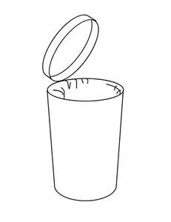

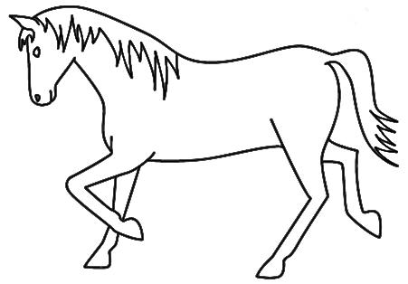

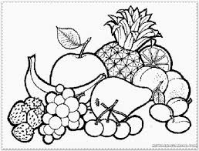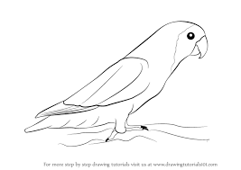

**Learn all hard words for dictation, question &answers and exercises from the book.**

************************